Business Services Administrator
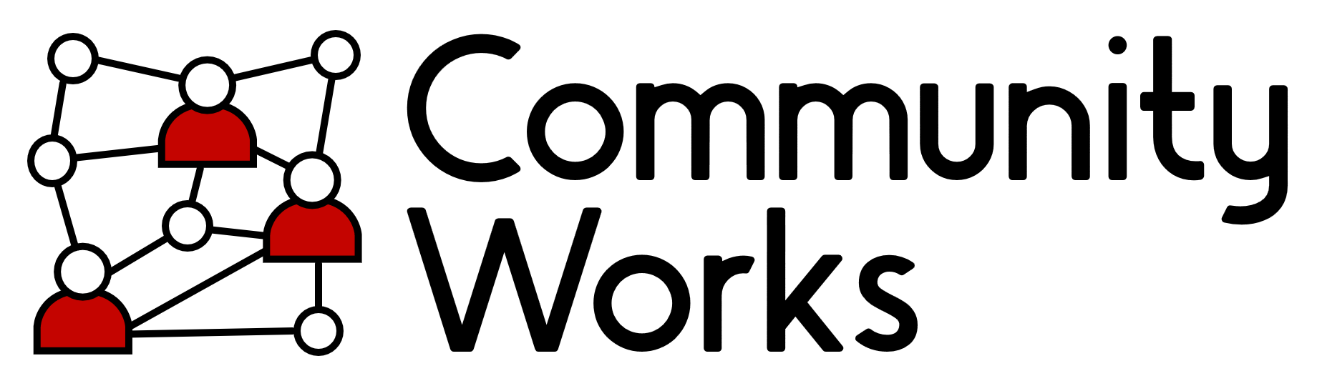
Help keep our Community Centre running smoothly and connected to the neighbourhood.
CommunityWorks is looking for an organised, reliable and proactive Business Services Administrator to join our core administration team.
This is an important role within CommunityWorks, providing practical and dependable administrative support across the charity’s day-to-day operations. You will help ensure that the Centre is well organised, our facilities and maintenance needs are coordinated, our communications are active and engaging, and essential administrative and financial tasks are completed accurately.
You will work closely with the CommunityWorks CEO and wider team, while having a high degree of autonomy and responsibility for managing your own workload.
About the role
As Business Services Administrator, you will provide a broad range of administrative and operational support across CommunityWorks.
The role has a particular focus on providing Friday administration cover, coordinating building maintenance and repairs, supporting our social media activity and undertaking light financial administration.
You will be someone who enjoys keeping things organised, is comfortable juggling different priorities and takes pride in making sure that the details are taken care of.
Working in a busy neighbourhood community centre, you will also be an important point of contact for staff, volunteers, community members, contractors and visitors. A friendly and helpful approach is therefore essential.

Hours: 18 hours per week
Period of employment: This post is initially funded for two years ( with possible extension subject to funding)
Holiday: 5 weeks per annum + public holidays
Salary: £25,989 per annum – pro rata (Pay Award pending)

To apply for this role please visit our website
to download the job description, person spec and application form.
You can also email HR@communityworksbradford.org.uk or phone 01274 200589 to have the job description, person spec and application form sent to you.
Closing date for Applications: Thursday 1st October 2026 at 5pm
Interviews: week commencing 12th of October 2026
If you want to find out more about the role please ask to speak to Vikrant Bhatia ( Community Works CEO) or email: vikrant.bhatia@communityworksbradford.org.uk

