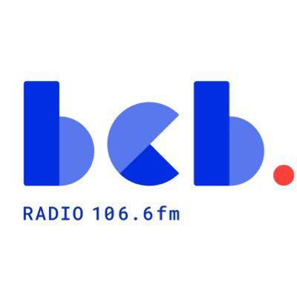

BCB Broadcast Support Worker: Person Specification June 2026

Purpose of the Role
To support the day-to-day operation of BCB’s speech based radio programmes, assist presenters and volunteers, ensure smooth studio and technical processes, and help deliver engaging, inclusive radio content that reflects and serves Bradford’s local community.

Essential Criteria:

Knowledge
- Understanding of community radio principles and values
- Knowledge of broadcasting procedures, studio operations, and programme production.
- Understanding of diversity, equality, and inclusion within community media settings.
- Basic knowledge of audio recording, editing, and broadcasting equipment.
- Awareness of local community issues.

Skills and Abilities
- Strong communication and interpersonal skills.
- Ability to support presenters, volunteers, and community contributors in a professional and approachable manner.
- Ability to troubleshoot minor technical issues during broadcasts.
- Good organisational and time-management skills.
- Ability to work effectively under pressure and meet broadcast deadlines.
- Accurate record-keeping and administrative skills.
- Ability to work independently and as part of a team.
- Competent IT skills, including email and databases

Experience
- Experience working in a media, broadcasting, communications or community-based environment.
- Experience supporting volunteers, staff, or members of the public.
- Experience using audio production or broadcasting software.
- Experience managing multiple tasks and priorities effectively.

Personal Qualities
- Enthusiastic and committed to community engagement.
- Reliable, flexible, and punctual.
- Positive and supportive approach to teamwork.
- Willingness to learn new skills and technologies.
- Creative and proactive in identifying solutions and opportunities.
- Commitment to promoting equality, diversity, and inclusion.
- Interest in news and current affairs

Desirable Criteria:

Knowledge
- Knowledge of community radio licensing and regulatory frameworks.
- Awareness of media regulations, broadcasting standards, and safeguarding requirements.
- Knowledge of local networks

Skills and Abilities
- Ability to train or mentor volunteers and new presenters.
- Skills in interviewing and programme planning.
- Ability to assist with social media and online content promotion.

Experience
- Previous experience within a community radio station.
- Experience of working with volunteers or community projects.
- Experience of producing or presenting radio programmes.

Qualifications
- Qualification in Radio Production, Journalism, Broadcasting, Communications, Community Development, or a related field.
- Relevant training in audio production, radio broadcasting, safeguarding.

Values and Behaviours

As well as the above knowledge, skills, experience, and qualifications it is also essential that the post-holder can demonstrate the following values and behaviours
- Commitment to the mission and values of BCB Community Radio
- Respect for community voices and participation.
- Integrity, professionalism, and accountability.
- A collaborative and inclusive approach to working with colleagues, volunteers, and community partners.
- Commitment to providing accessible and engaging content reflecting and serving Bradford’s diverse communities

Assessment Methods:
Application Form, Interview, Practical Assessment, and References.

