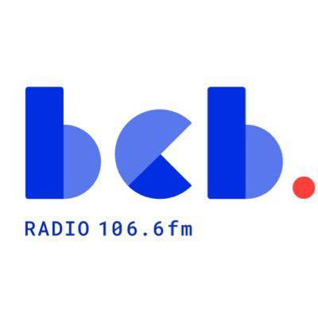

BCB Fundraising and Business Development Worker June 2026

Person Specification

Purpose of the Role
This new role is key to ensuring the long-term financial sustainability of the BCB. The BCB Fundraising and Business Development Worker will lead on BCB’s fundraising and income generation activities. This includes developing funding proposals, building relationships with local institutions, businesses and grant-making bodies, and devising and supporting community fundraising campaigns. You will also be a crucial member of the staff team, working alongside other staff to support and deliver the overall mission of BCB. The role is for 12 months funded by a grant from Ofcom Community Radio Fund.

Essential Criteria:
Experience
- Proven experience in fundraising and business development.
- Substantial grant writing experience with successful outcomes
- Experience of producing reports for boards and funders
- Experience planning and delivering projects or events.
- Experience working with community groups, charities, volunteers, or public-facing organisations.

Education and Qualifications
- Good standard of general education
- Evidence of relevant training or professional development in fundraising, marketing, communications, or community engagement.
Knowledge
- Knowledge of local business, key institutions and the funding landscape.
- Understanding of diversity, equality, and inclusion within community media settings.
- Knowledge of the voluntary, community and social enterprise sector
- Knowledge of Bradford’s diverse communities
- Very good financial awareness, understanding budgets and fundraising targets
- Knowledge of community radio funding models

Skills and abilities
- Excellent written and verbal communication skills.
- Very good digital and IT skills
- Excellent people skills and the ability to get on with a wide range of people
- Strong relationship-building and negotiation skills.
- Ability to work independently and manage multiple priorities.
- Ability to work effectively under pressure and meet deadlines.
- Excellent project management skills
- Ability to use databases and CRM systems to track donors and fundraising activities
- Ability to work with volunteers and small teams
Personal Qualities
- Enthusiastic, proactive and committed
- Reliable and punctual.
- Positive and supportive approach to teamwork.
- Flexible and able to adapt to change
- Enthusiasm for BCB’s mission as a community radio station
- Belief in community media and its social impact.

Desirable Criteria
- Experience of working in the voluntary or community sector.
- Experience of using social media, email campaigns, and community outreach for marketing and promotion
- Knowledge of community radio licensing and regulatory frameworks.
- Knowledge of local networks
- Familiarity with community radio or broadcasting environments.
- Skills in digital marketing, event planning, or creative fundraising.
- Degree or professional qualification in a relevant, associated field

Values and Behaviours

As well as the above knowledge, skills, experience, and qualifications it is also essential that the post-holder can demonstrate the following values and behaviours
- Commitment to the mission and values of BCB Community Radio
- Respect for community voices and participation.
- Integrity, professionalism, and accountability.
- A collaborative and inclusive approach to working with colleagues, volunteers, and community partners.
Assessment Methods: Application Form, Interview, Practical Assessment, and References.

